**Online Textbook Access for Hart Middle School Students:**  
  
**Big Ideas Math Course 2: A Bridge to Success**  
  
Step 1: To access online math text book and resources, go to [www.BigIdeasMath.com](http://www.BigIdeasMath.com)

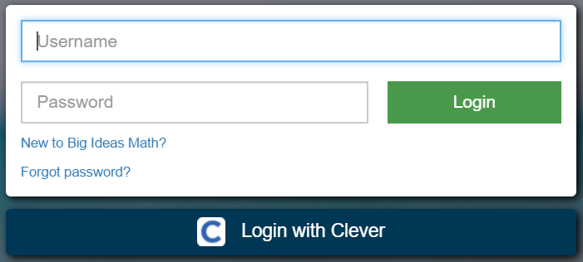

Step 2: Click the “Login with Clever” button and you   
 will be directed to a Clever page where you will   
 need to pick your school.

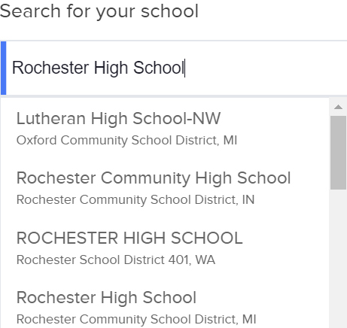

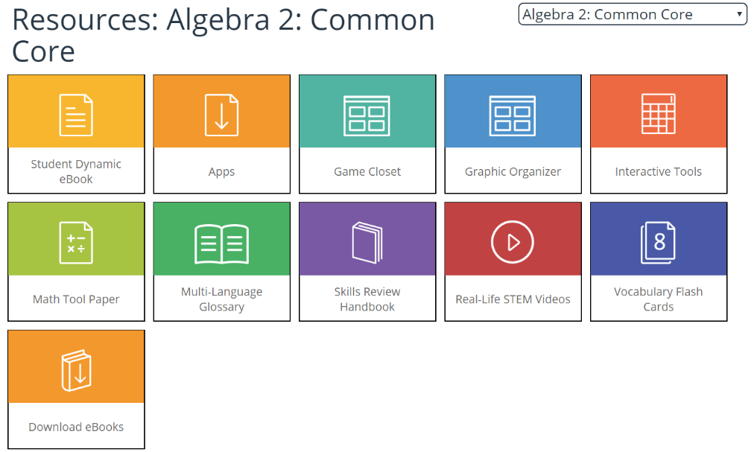Step 3: In the search box, type “Hart Middle School” and  
 choose Hart Middle School Rochester Community  
 School District, MI in the drop down menu.  
  
  
  
  
  
Step 4: Choose “Log in with Google” and enter your RCS google account username and password  
 (All student Google Apps accounts will begin with your student login ID followed by   
 @rcs‐k12.us (e.g. ajones4545@rcs‐k12.us).).  
  
  
Step 5: Once you have logged in, click on the Resources tab to view/access the online textbook and an array of   
 other resources to support you throughout the school year.



*(Note: If you are asked to select a textbook, please choose Course 2: A Bridge to Success)*

**Features of the Student Dynamic eBook:**  
  
The Student Dynamic eBook provides students with embedded 21st-century learning resources. Students not only have access to the complete textbook, but they can also explore interactive, digital enhancements, including English and Spanish audio support, Dynamic Investigations, and Lesson Tutorials.  
  
Once you have logged into Big Ideas Math, the Student Dynamic eBook   
is a yellow icon located under the resources tab.

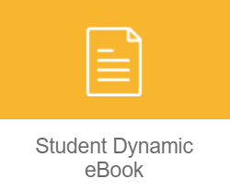

When you double click the icon a new tab will open with the Student Dynamic eBook. If it does not load properly, please check your popup blocker and “allow to load unsafe scripts”.  
  
**Once the book is open students may access the following features:**  
  
 1.) Any of the text can be read aloud to a student by placing your cursor on the text and clicking.  
  
 2.) Examples that have the icon in front of them will guide students through a step by step   
  
 tutorial video of the problem when the icon is clicked.





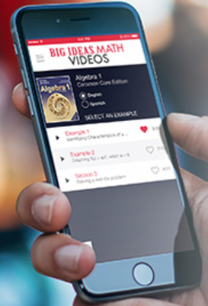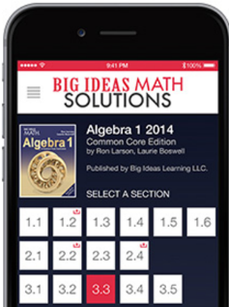  
 3.) Explorations that have the icon in front of them will allow students to investigate and apply   
  
 mathematical topics through interactive GeoGebra software.  
  
 4.) Examples and/or Examples that have the icon allow students to use the free, online calculation   
  
 and graphing capabilities of Desmos.  
   
 5.) Worked out solutions to odd numbered problems can be found by clicking on the text “Dynamic   
 Solutions available at BigIdeasMath.com” on the red banner of the Exercises header.







**Big Ideas Math App for Your Phone:**

Big Ideas Math offers two cell phone apps for your iPhone or Android.  
1.) Big Idea Math Videos – Tutorials for each Lesson  
2.) Big Ideas Math Solutions – Worked out solutions to   
 odd numbered problems  
Make sure you choose the correct textbook (Course 2: A Bridge to Success) in the app.